How Rails work with requests   
1. User enters URL  
2. Rails accepts incoming requests from a browser  
3. Rails decodes the request to find a controller [If URLS says <http://localhost:3000/say/hello> then Rails looks for controller named “say_controller”]   
(*Lis - 3. Это частный случай. Какой контроллер и какая акция выполняется, определяется routes*.)  
4. Calls an action method in that controller. In the case of the particular URL – it looks for method “hello”  
5. The controller then invokes a particular view to display the results to the user. It takes it from “views” directory and takes input from hello.html.erb to display in the browser. (Hello.html.erb - Rails processes this file through the ERB templating system, executing any embedded Ruby and substituting in values set up by the controller)

! When you generate a controller for the application it puts controllers and vies in standard places: controllers go into app/controllers, and views go into subdirectories of app/views.  
  
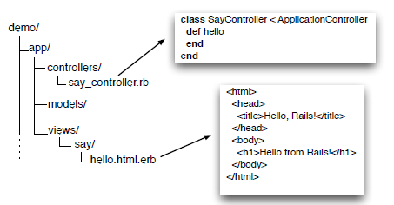

To generate controller in the application directory:  
**demo > rails generate controller Say hello goodbye**

**Say –** is a controller  
**hello goodbye –** name of the actions we intend this controller to support.

*

ERB filter

ERB is a filter that is installed as part of the Rails installation that takes an .erb file and outputs a transformed version. The output file is often HTML in Rails, but it can be anything. Normal content is passed through without being changed. However, content between <%= and %> is interpreted as Ruby code and executed. The result of that execution is converted into a string, and that value is substituted in the file in place of the <%=…%> sequence. For example, change hello.html.erb to display the current time:

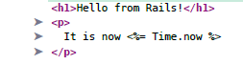

хочу пояснить насчет конструкции <%= file %> - почему тут не используют put

Лисяра: erb запрограммирован так, что сначала код руби, который стоит между <%= %> - выполняется, а потом результат его выполнения (то, что видишь в irb после выполнения любой строчки), преобразуется в строку и подставляется в HTML вместо <%= %>

(если ты в irb введешь puts "blah", ты увидишь, что результатом его выполнения является nil а nil.to_s - это пустая строка, поэтому в erb ничего и не появляется)

How ruby maps databases:  
  
So, an ORM layer maps:  
1. Tables to classes,   
2. Rows to objects, and   
3. Columns to attributes of those objects.   
Class methods are used to perform table-level operations, and instance methods perform operations on the individual rows.